**Assignment 1 report:**

**Maral Kasiri 018806318**

09/10/2018

This report contains the results from Perceptron Learning model.

Figure 1 depicts the first two images of “train.txt” data in grayscale.

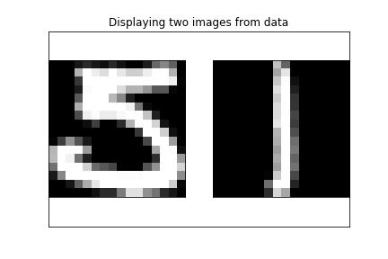

Figure 1

Figure 2 is the plot of training data features. The x axis is the average intensity and the y axis is the symmetry of the images. The red stars are the 1 images and the blue pluses are the 5 images.

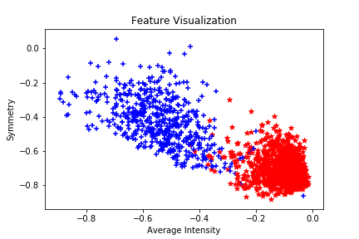

Figure 2

Figure 3 is the scatter plot of the test data and the separator. The equation of the separator is:

w[0]+ x1 w[1]+ x2 w[2]= 0

Where w is the array of our hypothesis and x1 is symmetry and x2 is the average intensity.

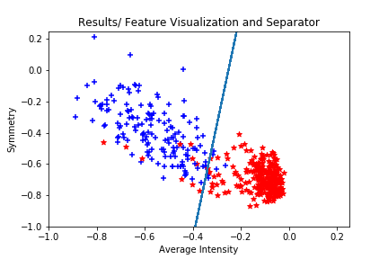

Figure 3